**SupersetID-6406181**

**PL/SQL Programming**

**Schema to be Created**

*CREATE TABLE Customers (*

*CustomerID NUMBER PRIMARY KEY,*

*Name VARCHAR2(100),*

*DOB DATE,*

*Balance NUMBER,*

*LastModified DATE*

*);*

*CREATE TABLE Accounts (*

*AccountID NUMBER PRIMARY KEY,*

*CustomerID NUMBER,*

*AccountType VARCHAR2(20),*

*Balance NUMBER,*

*LastModified DATE,*

*FOREIGN KEY (CustomerID) REFERENCES Customers(CustomerID)*

*);*

*CREATE TABLE Transactions (*

*TransactionID NUMBER PRIMARY KEY,*

*AccountID NUMBER,*

*TransactionDate DATE,*

*Amount NUMBER,*

*TransactionType VARCHAR2(10),*

*FOREIGN KEY (AccountID) REFERENCES Accounts(AccountID)*

*);*

*CREATE TABLE Loans (*

*LoanID NUMBER PRIMARY KEY,*

*CustomerID NUMBER,*

*LoanAmount NUMBER,*

*InterestRate NUMBER,*

*StartDate DATE,*

*EndDate DATE,*

*FOREIGN KEY (CustomerID) REFERENCES Customers(CustomerID)*

*);*

*CREATE TABLE Employees (*

*EmployeeID NUMBER PRIMARY KEY,*

*Name VARCHAR2(100),*

*Position VARCHAR2(50),*

*Salary NUMBER,*

*Department VARCHAR2(50),*

*HireDate DATE*

*);*

**Example Scripts for Sample Data Insertion**

*INSERT INTO Customers (CustomerID, Name, DOB, Balance, LastModified)*

*VALUES (1, 'John Doe', TO_DATE('1985-05-15', 'YYYY-MM-DD'), 1000, SYSDATE);*

*INSERT INTO Customers (CustomerID, Name, DOB, Balance, LastModified)*

*VALUES (2, 'Jane Smith', TO_DATE('1990-07-20', 'YYYY-MM-DD'), 1500, SYSDATE);*

*INSERT INTO Accounts (AccountID, CustomerID, AccountType, Balance, LastModified)*

*VALUES (1, 1, 'Savings', 1000, SYSDATE);*

*INSERT INTO Accounts (AccountID, CustomerID, AccountType, Balance, LastModified)*

*VALUES (2, 2, 'Checking', 1500, SYSDATE);*

*INSERT INTO Transactions (TransactionID, AccountID, TransactionDate, Amount, TransactionType)*

*VALUES (1, 1, SYSDATE, 200, 'Deposit');*

*INSERT INTO Transactions (TransactionID, AccountID, TransactionDate, Amount, TransactionType)*

*VALUES (2, 2, SYSDATE, 300, 'Withdrawal');*

*INSERT INTO Loans (LoanID, CustomerID, LoanAmount, InterestRate, StartDate, EndDate)*

*VALUES (1, 1, 5000, 5, SYSDATE, ADD_MONTHS(SYSDATE, 60));*

*INSERT INTO Employees (EmployeeID, Name, Position, Salary, Department, HireDate)*

*VALUES (1, 'Alice Johnson', 'Manager', 70000, 'HR', TO_DATE('2015-06-15', 'YYYY-MM-DD'));*

*INSERT INTO Employees (EmployeeID, Name, Position, Salary, Department, HireDate)*

*VALUES (2, 'Bob Brown', 'Developer', 60000, 'IT', TO_DATE('2017-03-20', 'YYYY-MM-DD'));*

**Exercise 1: Control Structures**

**Scenario 1:**

**Code**:

BEGIN

for cust IN (SELECT c.CustomerID, c.DOB, l.LoanID, l.InterestRate

FROM Customers c

JOIN Loans l ON c.CustomerID = l.CustomerID) LOOP

IF months_between(sysdate, cust.DOB) / 12 > 60 THEN

UPDATE Loans

SET InterestRate = InterestRate - 1

WHERE LoanID = cust.LoanID;

END IF;

END LOOP;

dbms_output.put_line('Discount applied for eligible senior customers.');

END;

/

**Output:**

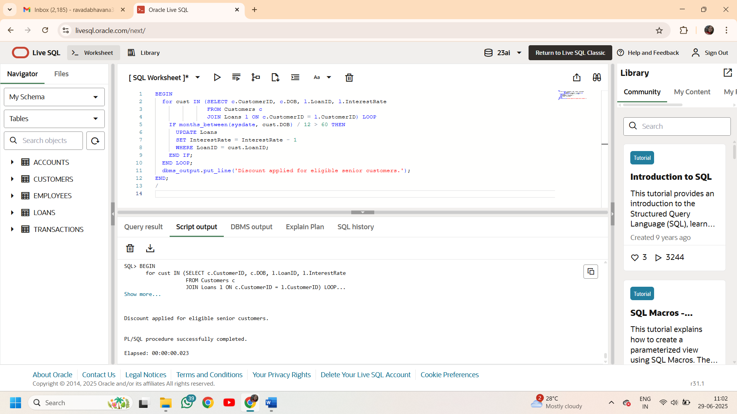

**Scenario 2:**

**Code:**

DECLARE

IsVIP boolean;

BEGIN

for cust in (select CustomerID,Name,Balance from Customers) loop

if cust.Balance>10000 then

IsVIP:=true;

else

IsVIP:=false;

end if;

if IsVIP then

dbms_output.put_line('customer '||cust.Name||' with ID'|| cust.CustomerID||'is a vip');

else

dbms_output.put_line('customer '||cust.Name||' with ID'|| cust.CustomerID||' is not a vip');

end if;

end loop;

END;

/

**Output:**

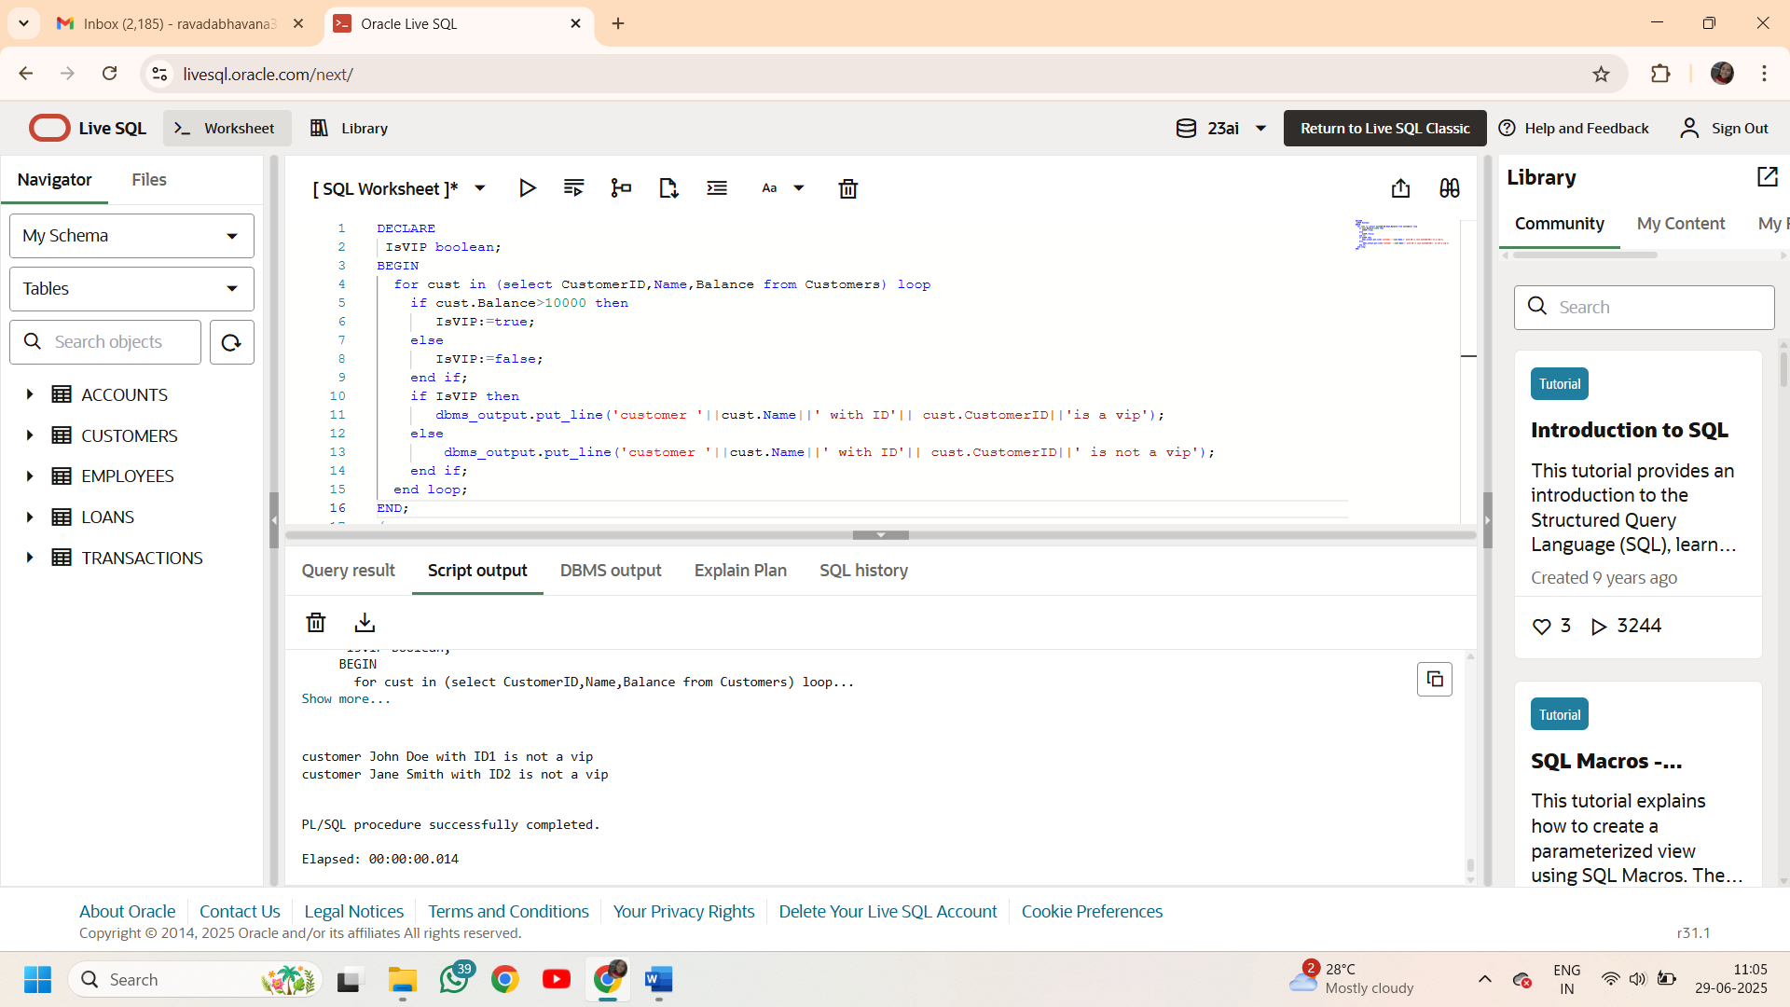

**Scenario 3:**

**Code:**

BEGIN

for loan in(select l.LoanID,l.CustomerID as loanCustID,l.EndDate,c.Name,c.CustomerID as custID

from Loans l join Customers c on

l.CustomerID=c.CustomerID

where l.EndDate between ADD_MONTHS(SYSDATE, 60) and ADD_MONTHS(SYSDATE,61))

loop

dbms_output.put_line('Reminder: customer '||loan.name||' with id'|| loan.loanCustID||' is due on'||to_char(loan.EndDate,'YYYY-MM-DD'));

end loop;

END;

/

**Output:**

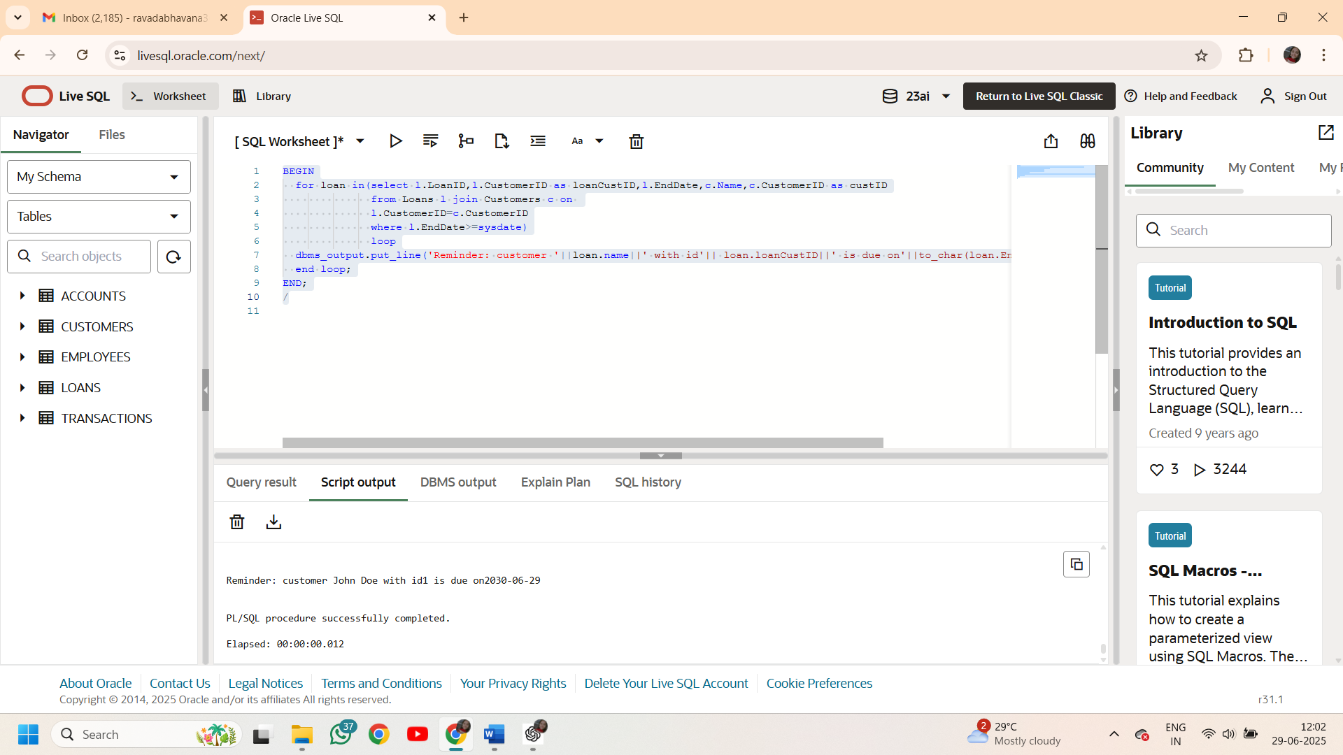

**Exercise 2: Error Handling**

**Scenario 1:**

**Code:**

create or replace procedure SafeTransferFunds(

    p_fromAccountId number,

    p_toAccountId number,

    amount number

)

AS

 source_balance number;

begin

select Balance into source_balance

from Accounts

where AccountID=p_fromAccountId;

if source_balance<amount then

raise_application_error(-20001,'insuffiecient funds');

end if;

update Accounts

set Balance=Balance-amount

where AccountID=p_fromAccountId;

update Accounts

set Balance=Balance+amount

where AccountID=p_toAccountId;

commit;

exception

when others then

dbms_output.put_line('transaction failed');

rollback;

end;

exec SAFETRANSFERFUNDS(1,2,1200);

**Output:**

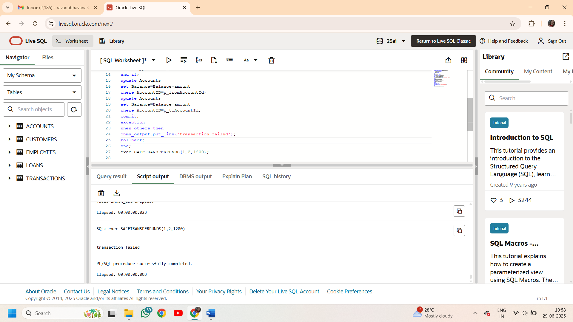

**Scenario 2:**

**Code:**

create or replace PROCEDURE UpdateSalary(

    p_employeeID number,

    p_percent number

)

as

v_old_salary number;

BEGIN

select Salary into v_old_salary

from Employees

where EmployeeID=p_employeeID;

update EMPLOYEES

set Salary=Salary+(Salary*p_percent/100)

where EmployeeID=p_employeeID;

dbms_output.put_line('salary updated successfully for employeeid '||p_employeeID);

EXCEPTION

when NO_DATA_FOUND THEN

dbms_output.put_line('error: employee with '||p_employeeID||' doesnt exist');

when others THEN

dbms_output.put_line('unexpected error occurred'||SQLERRM);

end;

/

exec UpdateSalary(2,10);

**Output:**

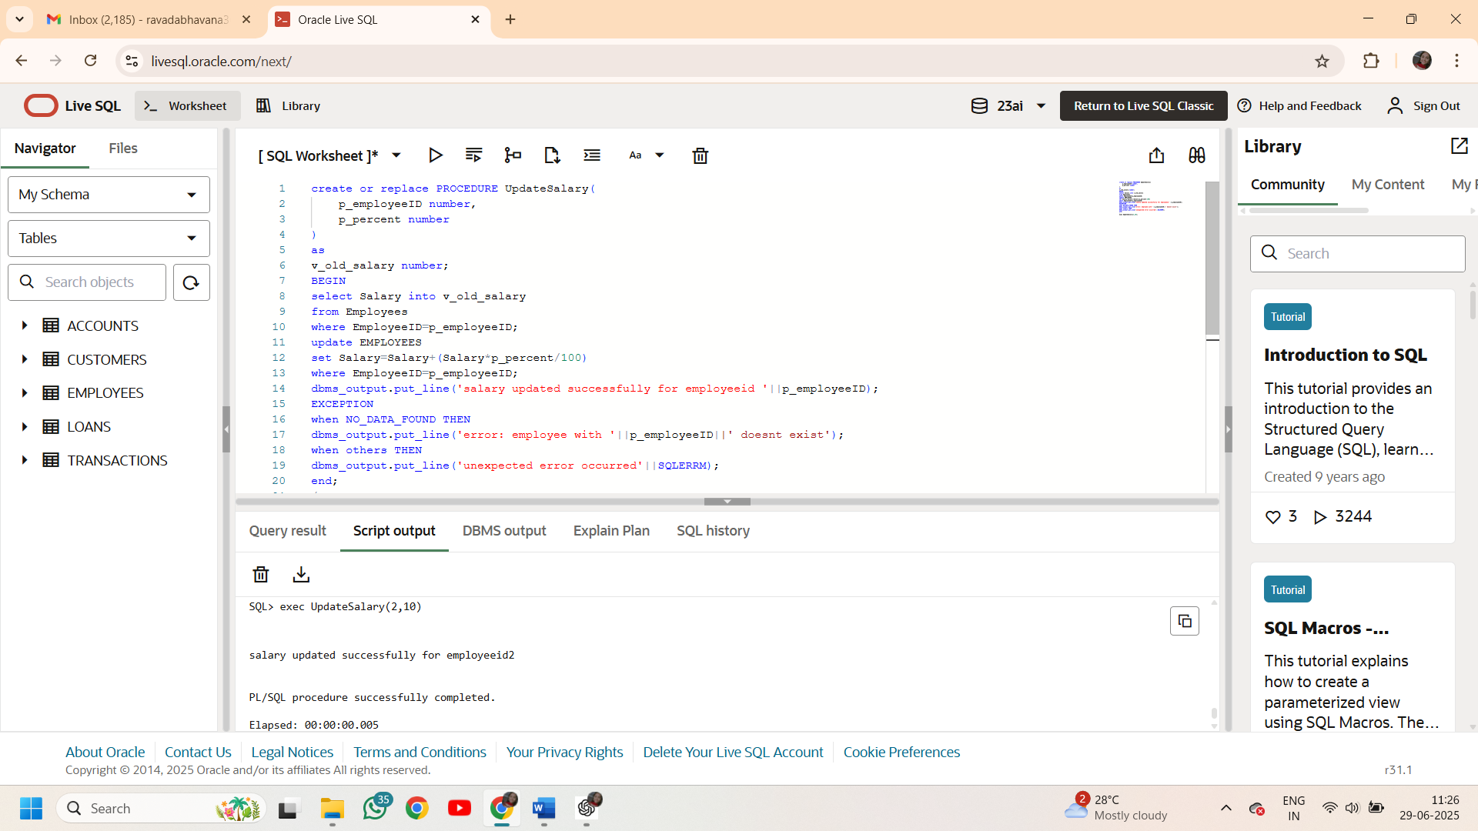

**Scenario 3:**

**Code:**

create or replace procedure AddNewCustomer(

    cust_ID number,

    cust_name Varchar2,

    cust_dob date,

    cust_bal number,

    last_modified date

)

as

begin

    insert into Customers(CustomerID,Name,DOB,Balance,LastModified)

    values(cust_ID,cust_name,cust_dob,cust_bal,last_modified);

    dbms_output.put_line('customer inserted successfully with id '||cust_ID);

exception

when DUP_VAL_ON_INDEX then

dbms_output.put_line('error: customer with id'||cust_ID||'already exists');

when others THEN

dbms_output.put_line('unexpected error'||SQLERRM);

end;

/

exec AddNewCustomer(3,'Rosy',TO_DATE('1985-12-15','YYYY-MM-DD'),1000,SYSDATE);

**Output:**

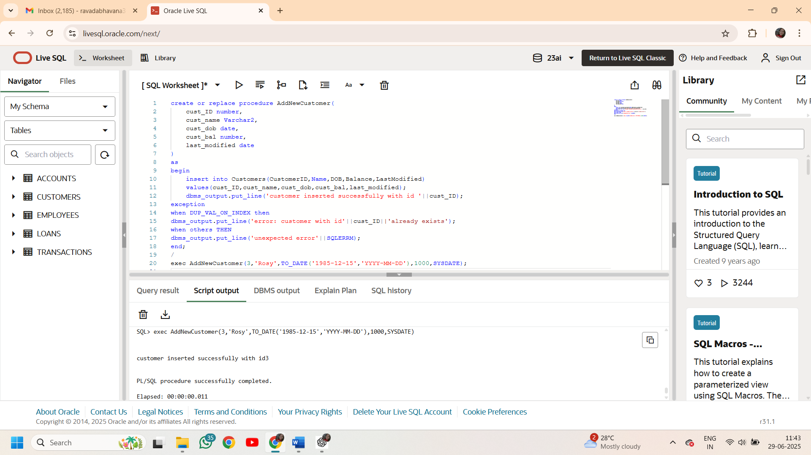

**Exercise 3: Stored Procedures**

**Scenario 1:**

Code:

create or replace procedure ProcessMonthlyInterest as

account_count NUMBER:=0;

BEGIN

update Accounts

set Balance=Balance+(Balance*0.01),LastModified=SYSDATE

where AccountType='Savings';

account_count:=SQL%rowcount;

dbms_output.put_line(account_count||' accounts have been updated with 1% interest');

commit;

END;

/

exec ProcessMonthlyInterest;

Output:

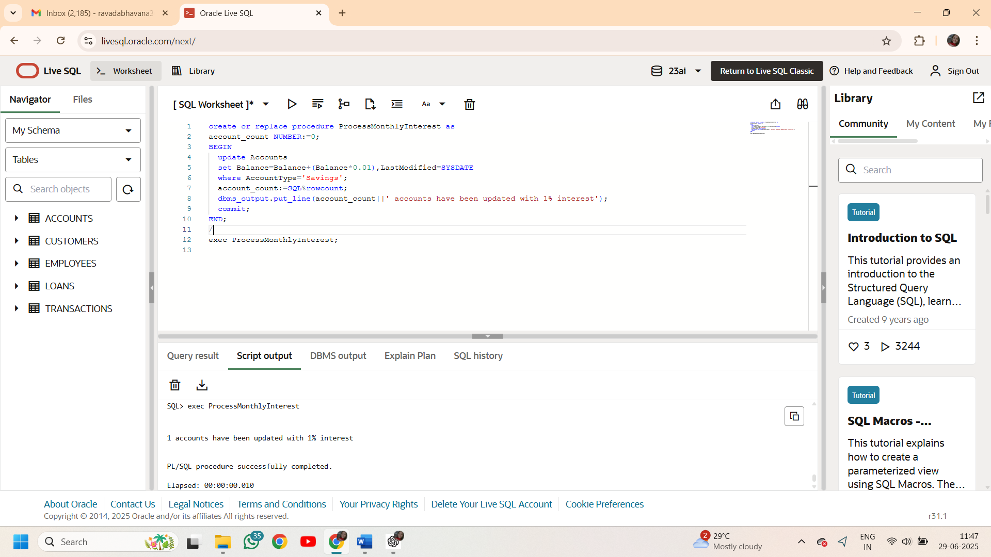

**Scenario 2:**

**Code:**

create or replace procedure UpdateEmployeeBonus(

v_department varchar2,

v_bonuspercentage number)

as

v_count number:=0;

BEGIN

update Employees

set salary=salary+(salary*v_bonuspercentage/100)

where Department=v_department;

v_count:=SQL%rowcount;

dbms_output.put_line(v_count||' employees from '||v_department||' department got a bonus of '||v_bonuspercentage||'%');

commit;

END;

/

exec UpdateEmployeeBonus('IT',8);

**Output:**

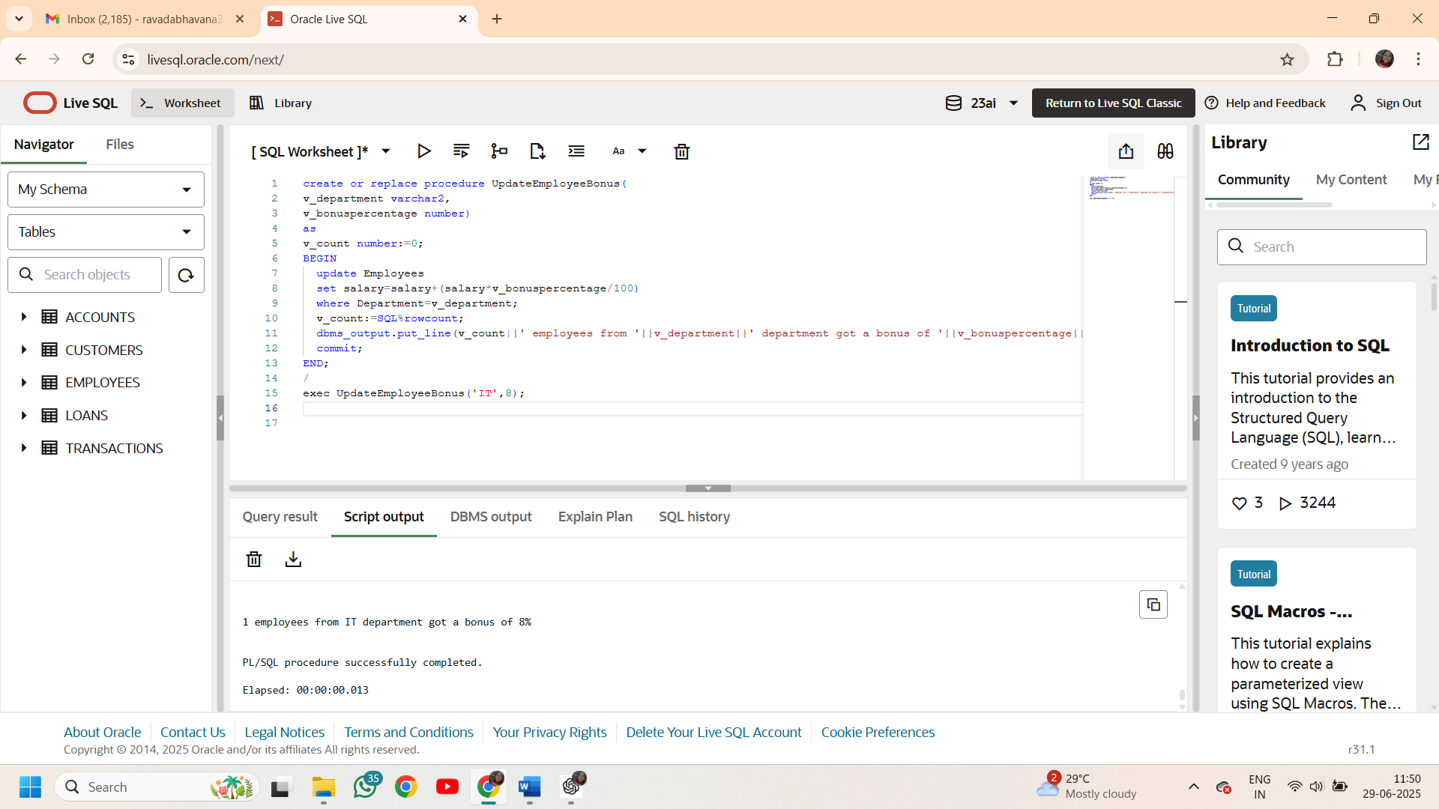

**Scenario 3:**

Code:

create sequence Transaction_seq start with 1000 increment by 1;

create or replace procedure TransferFunds(

p_FromAccountId number,

p_ToAccountId number,

p_amount number) as

p_bal number;

BEGIN

if p_FromAccountId=p_ToAccountId then

raise_application_error(-20002,'self transfer is not possible');

end if;

select Balance into p_bal from Accounts

where AccountID=p_FromAccountId;

if p_bal<p_amount then

raise_application_error(-20001,'sorry! insufficient balance in the source account');

end if;

update Accounts

set Balance=Balance-p_amount,

LastModified=SYSDATE

where AccountID=p_FromAccountId;

update Accounts

set Balance=Balance+p_amount,

LastModified=SYSDATE

where AccountID=p_ToAccountId;

INSERT into Transactions(TransactionID, AccountID, TransactionDate, Amount, TransactionType)

values (Transaction_seq.NEXTVAL,p_FromAccountId,SYSDATE,p_amount,'Withdrawal');

INSERT into Transactions(TransactionID, AccountID, TransactionDate, Amount, TransactionType)

values(Transaction_seq.NEXTVAL,p_ToAccountId,SYSDATE,p_amount,'Deposit');

dbms_output.put_line(p_amount||' has been tranferred to account with id '|| p_ToAccountId);

commit;

END;

/

exec TransferFunds(1,2,300);

Output:

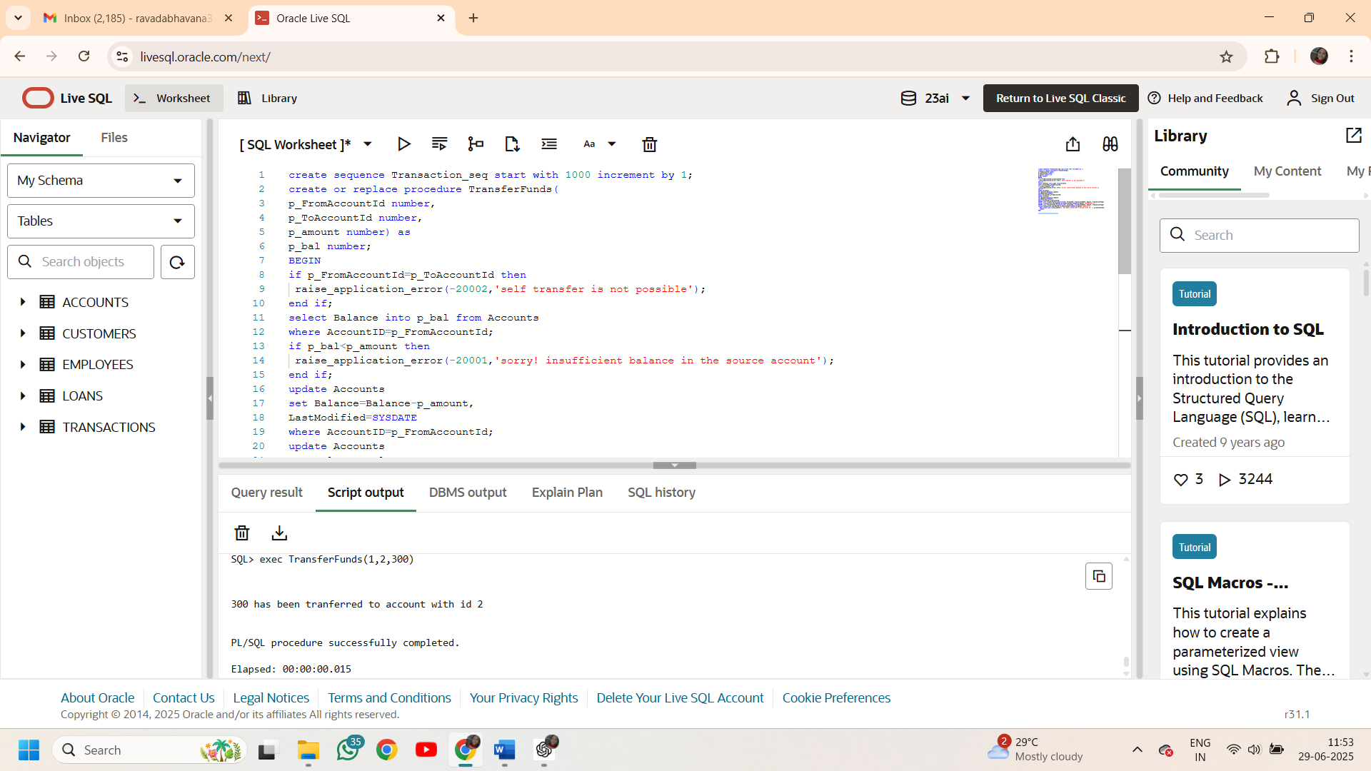

**Exercise 4: Functions**

**Scenario 1:**

**Code:**

create or replace function CalculateAge(

    f_dob date

)return number

is

v_age number;

begin

    v_age:=floor(months_between(sysdate,f_dob)/12);

    return v_age;

end;

/

SELECT CalculateAge(TO_DATE('1995-06-15','YYYY-MM-DD')) AS Age FROM dual;

**Output:**

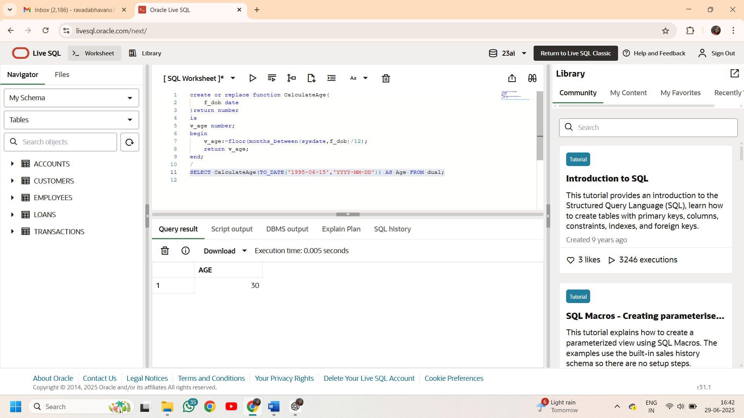

**Scenario 2:**

**Code:**

create or replace function CalculateMonthlyInstallment(

    loan_amount number,

    interest_rate number,

    loan_duration number

)return NUMBER

is

v_emi number;

v_monthly_rate number:=interest_rate/(12*100);

v_total_months number:=loan_duration*12;

BEGIN

    if v_monthly_rate=0 then

    v_emi:=loan_amount/v_total_months;

    else

    v_emi:=(loan_amount*v_monthly_rate*power(1+v_monthly_rate,v_total_months))/(power(1+v_monthly_rate,v_total_months)-1);

    end if;

return round(v_emi,2);

end;

/

SELECT CalculateMonthlyInstallment(100000, 10, 5) AS EMI FROM dual;

**Output:**

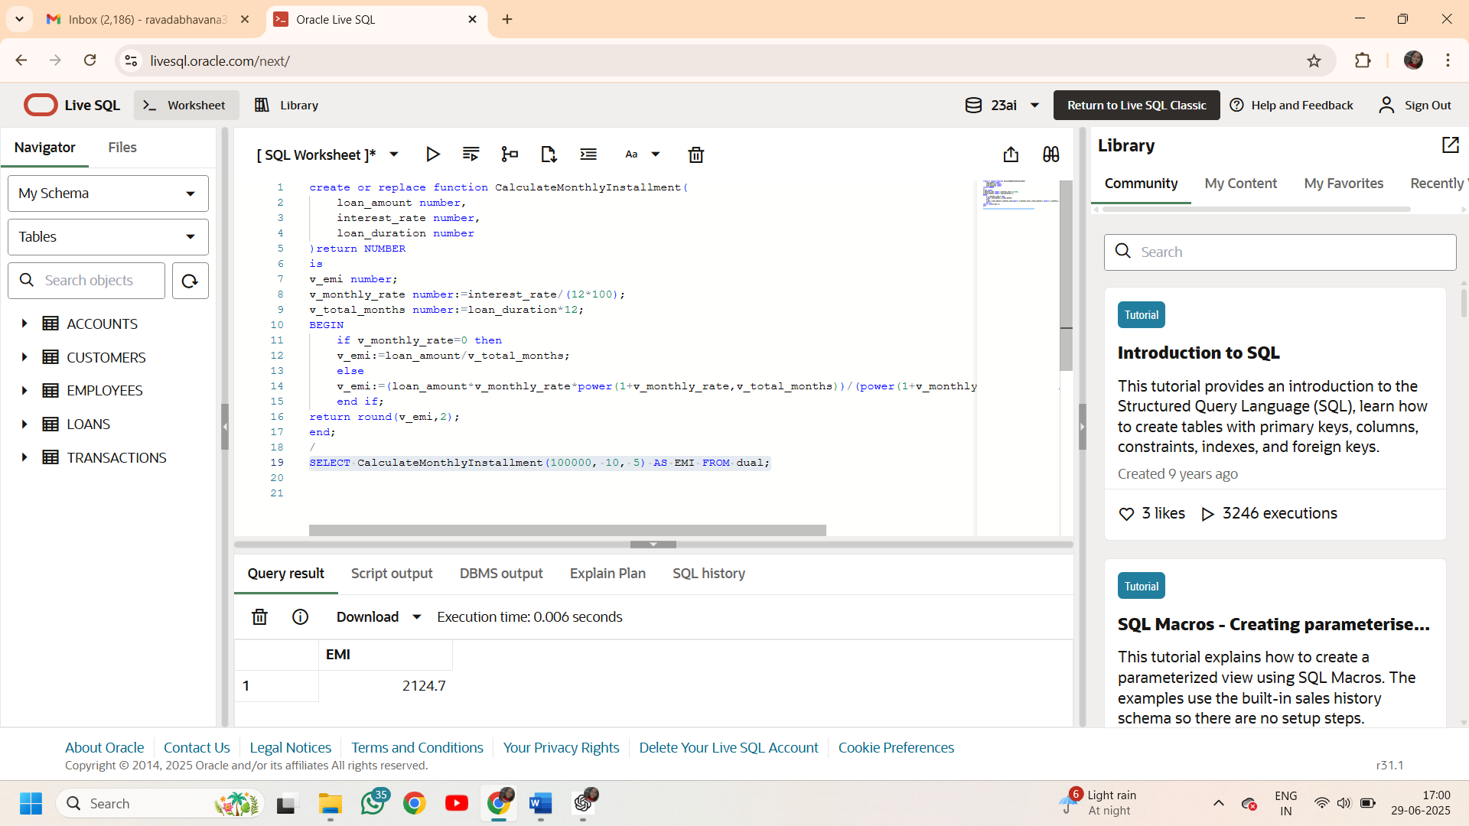

**Scenario 3:**

**Code:**

create or replace function HasSufficientBalance(

    f_account_id number,

    f_amount number

)return boolean

is

v_bal number;

begin

select Balance into v_bal from Accounts

where AccountID=f_account_id;

return v_bal>=f_amount;

end;

/

declare

result boolean;

begin

    result:=HasSufficientBalance(1,200);

    if result THEN

    dbms_output.put_line('sufficient balance');

    end if;

EXCEPTION

when NO_DATA_FOUND then

 dbms_output.put_line('Insufficient balance');

when others then

 dbms_output.put_line('Insufficient balance');

end;

/

**Output:**

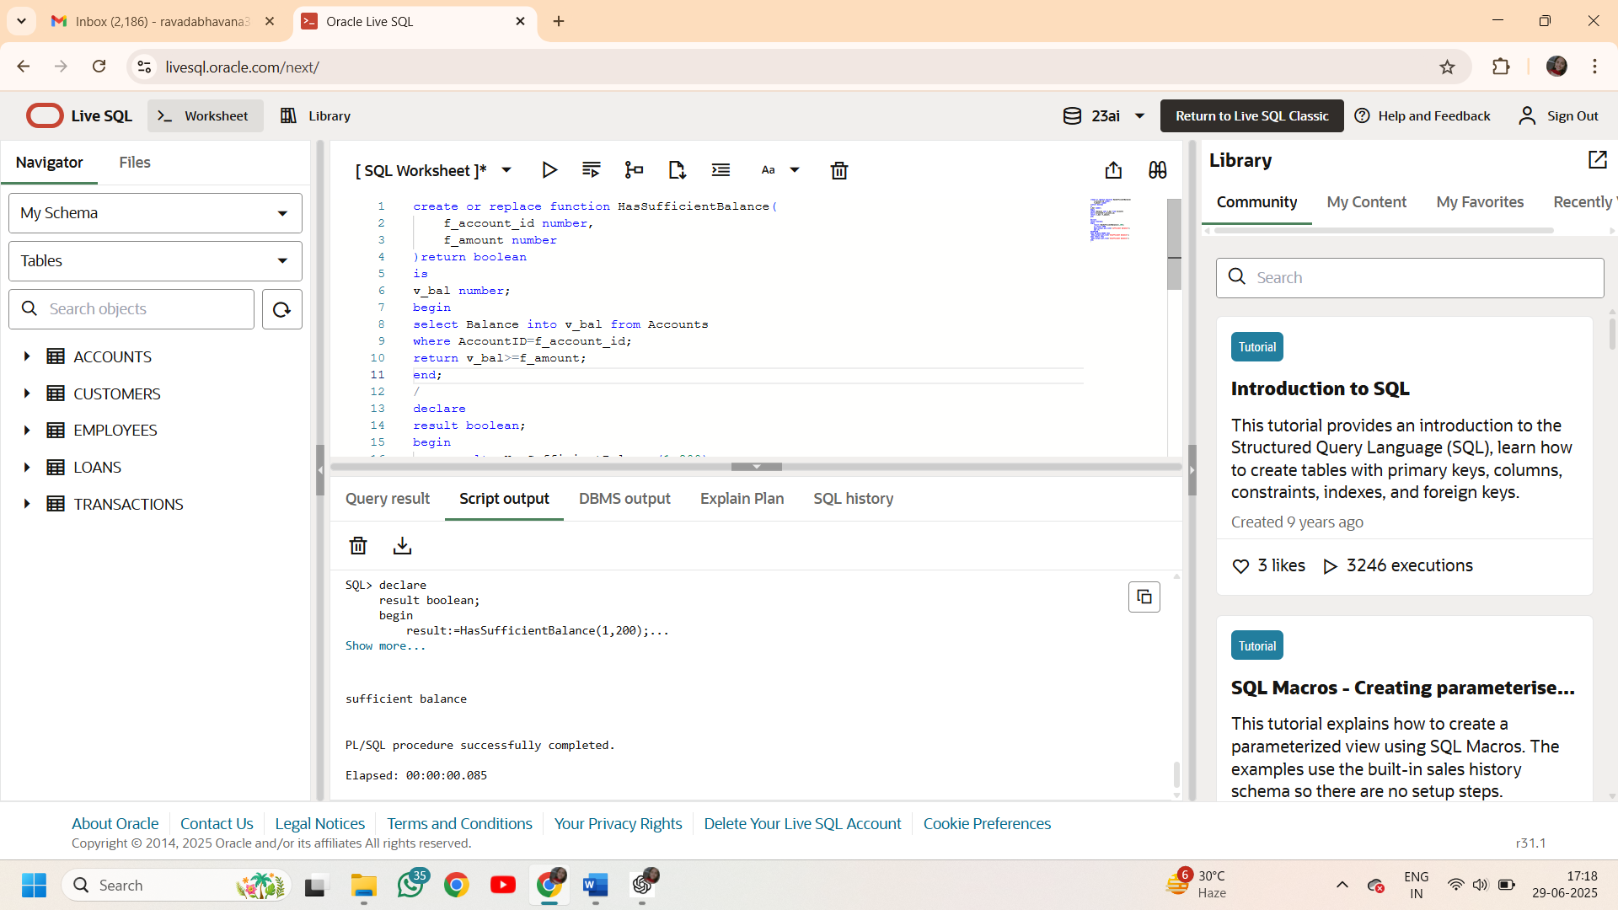

**Exercise 5: Triggers**

**Scenario 1:**

**Code:**

create or replace trigger UpdateCustomerLastModified

before UPDATE on Customers

FOR EACH ROW

begin

    :NEW.LastModified := sysdate;

end;

/

--to update

update Customers set Name='Bhavana' where CustomerID=1;

--to check

select LastModified from Customers where CustomerID=1;

**Output:**

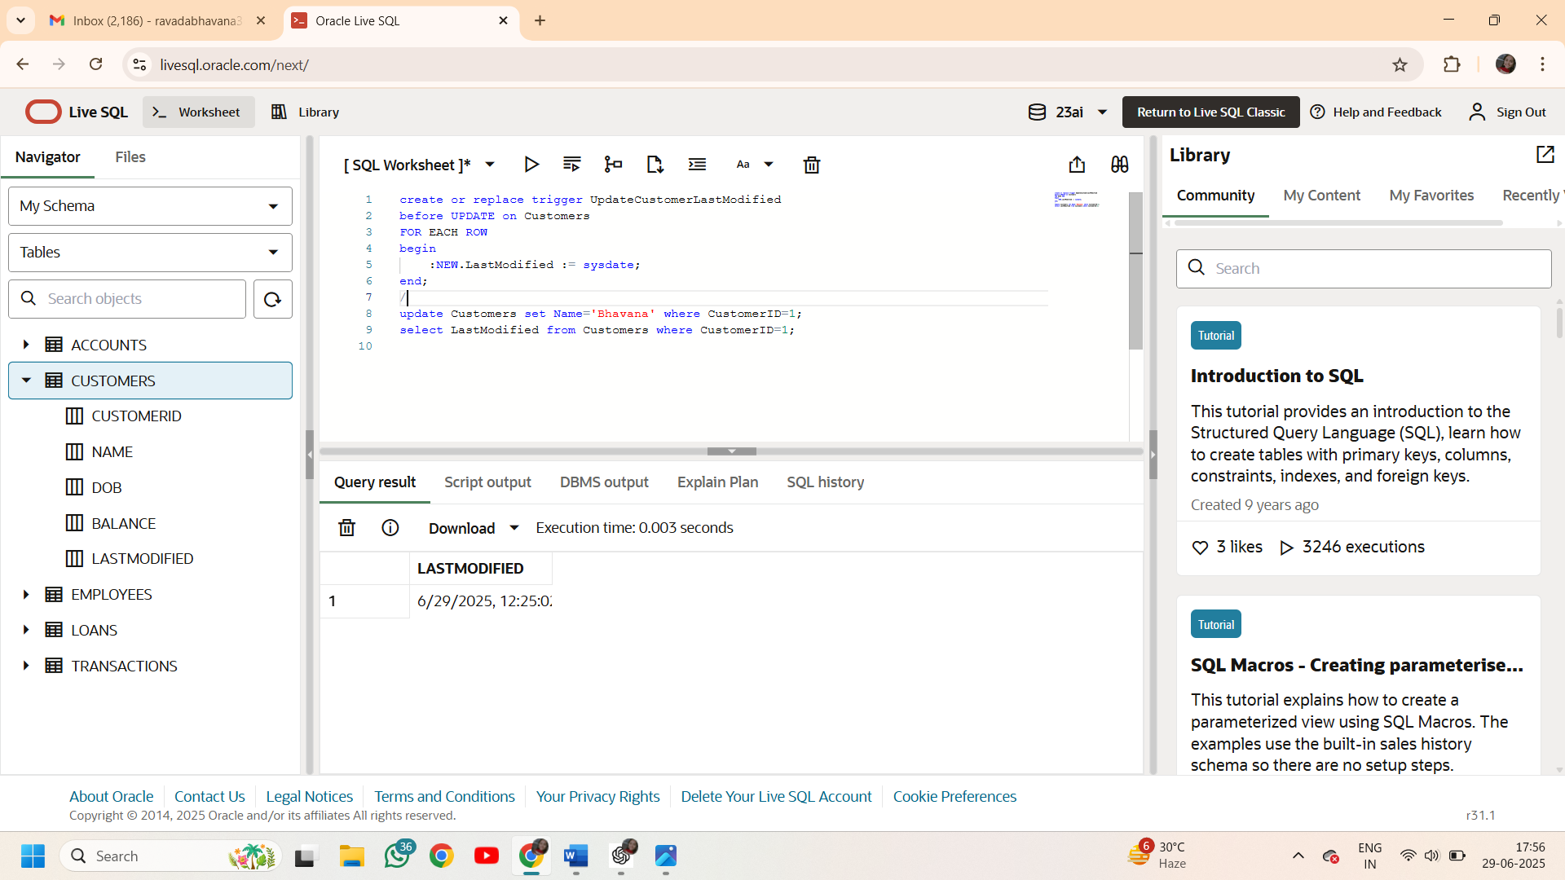

**Scenario 2:**

**Code:**

create table AuditLog (

    AuditID number GENERATED BY DEFAULT AS IDENTITY PRIMARY KEY,

    TransactionID NUMBER,

    AccountID NUMBER,

    TransactionDate DATE,

    Amount NUMBER,

    TransactionType VARCHAR2(10),

    LoggedAt DATE DEFAULT SYSDATE

);

create or replace trigger LogTransaction

after insert on Transactions

for each ROW

BEGIN

    insert into AuditLog(TransactionID,AccountID,TransactionDate,Amount,TransactionType)

    values(:NEW.TransactionID,:NEW.AccountID,:NEW.TransactionDate,:NEW.Amount,:NEW.TransactionTypE);

end;

/

INSERT INTO Transactions (TransactionID, AccountID, TransactionDate, Amount, TransactionType)

VALUES (3,1,SYSDATE,100,'Deposit');

select * from Auditlog;

**Output:**

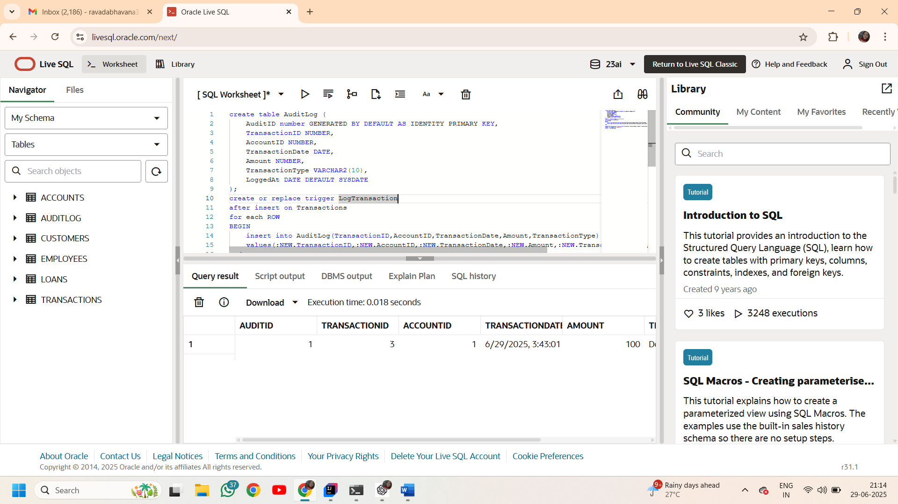

**Scenario 3:**

**Code:**

create or replace trigger CheckTransactionRules

before insert ON Transactions

FOR EACH ROW

declare

    v_balance NUMBER;

begin

    select Balance into v_balance

    from Accounts

    where AccountID = :NEW.AccountID;

    if :NEW.TransactionType = 'Withdrawal' AND :NEW.Amount > v_balance THEN

        RAISE_APPLICATION_ERROR(-20001, 'Insufficient balance for withdrawal');

    END IF;

    IF :NEW.TransactionType = 'Deposit' AND :NEW.Amount <= 0 THEN

        RAISE_APPLICATION_ERROR(-20002, 'Deposit amount must be positive.');

    END IF;

end;

/

INSERT INTO Transactions (TransactionID, AccountID, TransactionDate, Amount, TransactionType)

VALUES (4,1,SYSDATE,999999,'Withdrawal');

**Output:**

